WHY DON'T MORE PEOPLE INSTALL HEAT PUMPS?

Andrew Gigiel MSc FInstR CCC Consultants Moorlynch Somerset
Christopher Jessop BSc Independent Energy Consultant Marloes Pembrokeshire West Wales

INTRODUCTION

Scope of this paper
This paper covers electrically driven vapour compression air source heat pumps (ASHPs) for the domestic and light commercial building sectors providing
- domestic hot water (DHW) plus space heating via low pressure hot water (LPHW)
- domestic hot water (DHW) plus space heating via warm air.
On-gas-grid and off-gas-grid locations are considered.

Direct heat pump systems, i.e. refrigeration working fluid distributed through occupied spaces are excluded; we concentrate on ASHPs because the mass roll-out of heat pumps to replace natural gas boilers required to satisfy UK carbon reduction targets is not possible with ground source technology.

Climate Change: the situation confronting us
Legally-binding UK climate change mitigation targets commit us to an 80% cut in carbon emissions by 2050; accordingly, fossil fuel power generation must be phased out by that date. Although some progress has been made in that direction, British renewable energy investment lags far behind Denmark and Germany.

Because the domestic sector accounts for 28% of all UK energy final consumption, we must phase out natural gas as a cooking and domestic heating fuel: therefore, while domestic gas boilers are currently installed at a rate of 1.6 million pa [1], after 2020 heat pumps will need installing at a rate of 1 million pa [1]; meanwhile, the current heat pump installation rate is 16,000 pa [2].

As many more heat pumps are being installed annually in other countries, this paper asks why the UK installation rate is relatively low; meanwhile a pressing question is, how to source the “green” electricity needed for a very large heat pump fleet?

DISCUSSION

Domestic heat pumps: the current situation in Britain
Firstly, let us compare installation costs with “business as usual” [2]:
ASHP £6000 - £8000 Gas central heating £3000 - £4000

Now, comparing price of delivered heat [2]:
ASHP 4.3p / kWh_{th} Gas CH 3.7p / kWh_{th}
N.B. In running cost terms, ASHPs are somewhat more attractive in areas off the natural gas grid [2]:

 | Natural Gas | Oil | LPG | Coal
Fuel price p/kWh | 3.63 | 4.06 | 6.53 | 4.15
C0₂/kWh | 0.184 | 0.245 | 0.214 | 0.315

Eligible ASHP installations (with heat metering) currently earn an annual Renewable Heat Incentive (RHI) bonus of 10.18p / kWh_{th}, to a maximum of 20,000 kWh_{th} pa. However, under BEIS degression rules increased heat pump take-up means reduced subsidies; so, to be widely accepted, subsidy-free ASHPs will have to offer the general public a “better deal“ than natural gas central heating.

So – what needs to be done differently to get British ASHP installation rates up from the current 16,000 annually to more than 1,000,000 a year?

Problem 1: Marketing

People are finding it increasingly difficult to afford a house, so the last thing they want is to increase their mortgage commitments by purchasing a capital intensive heating system. Therefore, householders will be much more attracted to heat pumps if our industry revises its marketing policy and offers to lease them; indeed, householders might prefer leasing heat pumps to purchasing gas boilers. With leasing –
- A supplier with commercial “clout” who bulk buys equipment can bring prices down;
- Householders needn't fear technical stranding: the supplier will steadily replace older heat pumps;
- Householders never receive shock bills: the fixed lease fee gives fully comprehensive cover;
- It is in the supplier’s interests to maximise reliability by continuously monitoring performance;
- The supplier guarantees to “fix quickly, or replace”
- Accordingly, there can be no on-site refrigeration work: this achieves efficient use of skilled staff – who work in optimum conditions, ensuring maximum equipment reliability.

Problem 2: Billing

As regards technical issues, heat pump leasing guarantees peace of mind for the householder; but an inevitable consequence of the “smart grid” is ever more complicated electricity tariffs, especially if one wants the best possible value. Heat pumps, even efficient ones, use a lot of electricity; householders won't like having to regularly shop around for the best power purchase deal: much better if the heat pump supplier uses their expertise and purchasing clout to do that for them.

The solution is, copy the district heating model: the householder receives a single bill comprising
- Standing charge for provision of service;
- Quarterly charge for the supply of metered heat.

This is feasible if the heat pump has a smart electricity sub-meter; note that a heat pump supplier paying for power will be commercially as well as morally obliged to minimise running costs. Furthermore, canny heat pump suppliers would offer householders “good deals” re home-generated PV power.

Problem 3: Installation

ASHPs should never be built into properties: firstly, that is incompatible with leasing; and, anyway, the “Gig Economy” and zero-hours contracts mean that people find it increasingly hard to take time off to allow third parties access inside their homes. The solution is a “cassette” type external mounting arrangement for any sort of heating equipment, with everything standardised across all manufacturers (Figure 1).

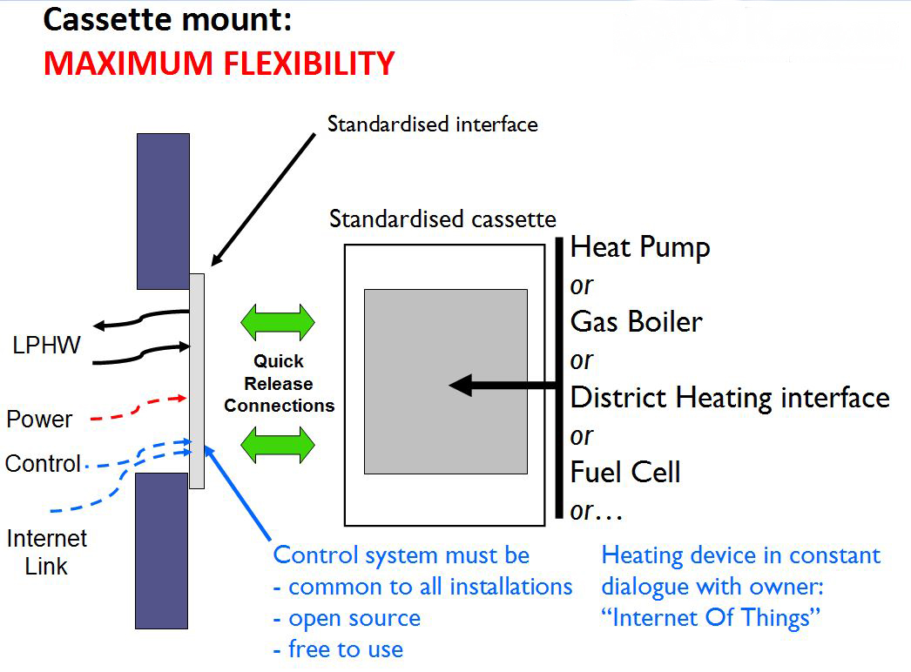

Figure 1: Cassette Mount for heat pump or other heat source

The dwelling’s services run to an interface bulkhead in an external wall; the heat pump (or other heat source) is mounted in a cassette; all connections are quick-release. A common control protocol makes all equipment compatible; an “Internet Of Things” approach ensures continuous performance monitoring.

With a cassette system, the heat pump supplier should never have to enter the premises: technicians can check or replace units without the householder attending. In the longer term, heat pump maintenance/replacement could even be robotic, entrusted to driverless vehicles.

Problem 4: Capacity vs installation cost

Our industry finds it difficult to make architects and heating engineers understand that you should not size a heat pump as you might a gas boiler. Firstly, there is typically a linear relationship between kW rating and price. Secondly, with higher capacity heat pumps come “knock-on” penalties: larger power supply, higher electrical infrastructure costs, higher electricity standing charges, a greater defrost power demand. Finally, larger heat pumps are typically noisier, heavier, and bigger.

With leasing, the heat pump supplier’s tariff can encourage specifiers for new-build projects towards lower capacity ASHPs which are “run harder”; this requires some thermal storage, of course. Meanwhile should the heat demand of an existing leasing customer increase (e.g. house extended to accommodate parents) or decrease (external insulation fitted) with the proposed cassette arrangement the existing heat pump is easily exchanged for one of a different capacity.

Problem 5: ASHP performance

These are the inevitabilities of ASHPs, and everyone in the industry is aware of them; nevertheless they should be re-stated here because they have such a strong bearing on the discussion of thermal storage:
- COP is highest when heat demand is lowest, both season by season and over any 24 hour day;
- An ASHP’s output is lowest when heating demand peaks, i.e. minimum ambient temperature.

In most centrally heated homes, the householder arranges for morning and evening heating periods; superimposed on this diagram of the typical heat demand profile is the incidence of an ASHP’s best and worst daily COPs, based on external ambient temperature (Figure 2).

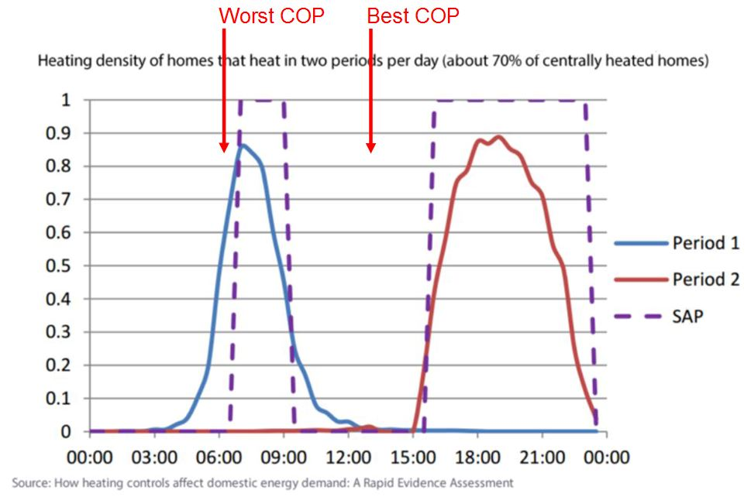

Figure 2: Typical UK house heating load, ASHP best & worst COP points superimposed

Problem 6: UK electricity grid constraints

When one tries to factor in the availability of electricity to operate a multi-million-unit fleet of domestic ASHPs, the power transmission problems are obvious: without thermal storage, not only would we be trying to run a huge number of heat pumps at far below optimum ambient temperature conditions, but the peak domestic space heating demand periods coincide almost exactly with peak demand on the UK National Grid. Nevertheless at the moment many people are, very unwisely, marketing heat pump systems with little or no thermal storage capability (Figure 3).

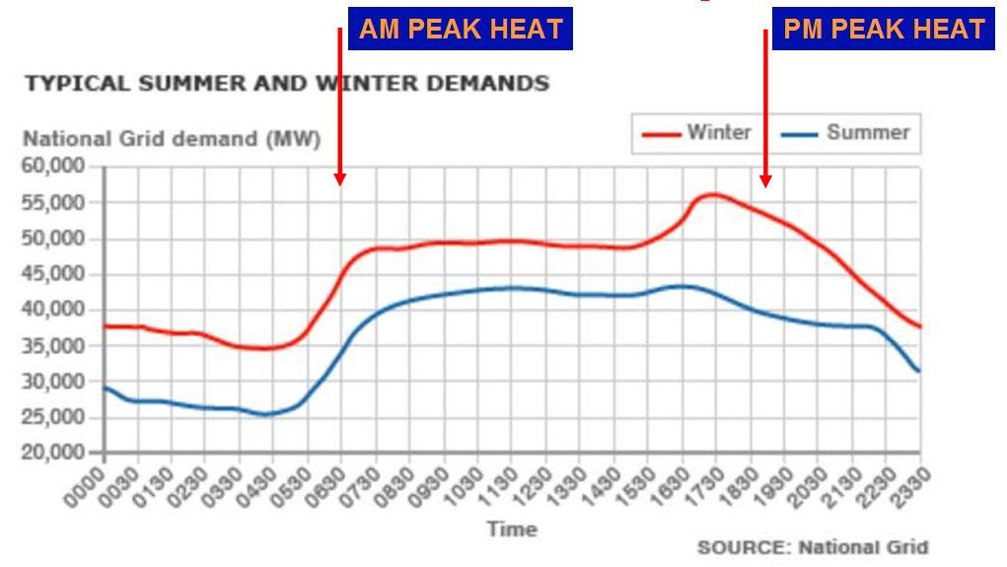

Figure 3: National Grid load profiles with home heating morning & evening peaks superimposed

Problem 7: Time-of-day tariffs

Electricity Grid supply and demand mismatches are a growing issue as we increasingly move from baseload and peak fossil fuel generation to weather-dependent renewables; how do energy providers plan to cope? The answer is, time-of-day (TOD) tariffs. With these, just as with railway ticket pricing, the amount you pay depends on how many other people are demanding a share of the available resource at the same time. Below is an example of a contemporary TOD tariff [3].

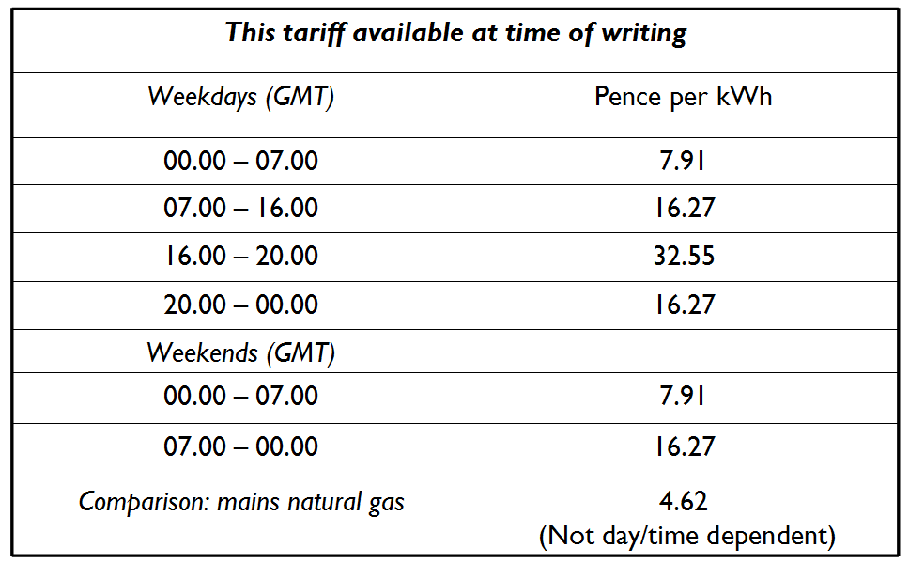

The argument for smart metering has long been, “it puts you in control” – and this is true with TOD tariffs: you always know the price of power, as and when you use it. TOD tariffs benefit electricity generators and distributors; so, in future, householders seeking the best deals on electricity must opt for them, and start to prudently schedule their electricity use by changing their behaviour (e.g. a slow cooker stew made during the day, not an oven casserole in the evening).

The huge problem with an “out of the box” ASHP installation which incorporates little or no thermal storage is that if it is scheduled conventionally for space heating (early morning, and then late afternoon to mid evening) it will run up large electricity bills on a smart tariff – and in the future it will prove unpleasantly expensive to run even on a flat rate tariff, because charges for these will surely be raised to encourage people down the TOD path.

Problem 8: 24 hour futures tariffs

The “smarter” the tariff, the better the deal: inevitably, this is the way that electricity pricing will go – and already we have moved beyond the TOD tariff. As the operators of a currently-available “Futures Tariff” [4] explain, “At 4pm every day, your unit rates are updated for the next 24 hours, based on the wholesale market rates. As you use electricity we'll use the half-hourly data from your smart meter to calculate your charges.”

Figure 4 shows actual 24 hour futures tariff figures from a particular day in Autumn 2018 when so much wind power was being generated in Scotland, the Grid suffered an “energy glut”: for 4½ hours electricity was cheaper than natural gas; for 1½ hours, indeed, customers were being paid to consume power!

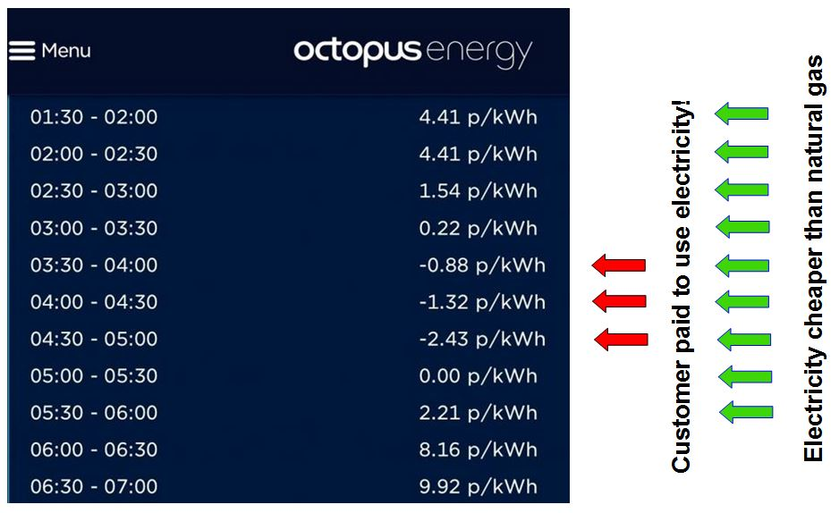

Figure 4: Extract from an actual 24 hour Futures Tariff (electricity)

The above is an extreme example; the point is, no ordinary householder could expect to manage their heat pump (and, inevitably, its means of storing heat) to make the most of such a tariff. However a heat pump supplier with a large leased fleet who charges householders for the supply of heat could set up the necessary “Internet Of Things” to make the most of even very “fluid” tariffs; furthermore, a heat pump supplier with a very large leased fleet might start to negotiate for power with generators and District Network Operators (DNOs) – to the mutual benefit of all parties.

Problem 9: Domestic PV generation

Solar photovoltaic (PV) equipment prices have fallen so much, HM Government argues that subsidies for domestic PV installations are no longer justified: installations completed after March 2019 will not receive Feed-In Tariff (FIT) payments. More controversially, at the time of writing HMG also proposes that owners of installations completed after March 2019 will be paid nothing for any surplus PV electricity which gets fed into the grid – notwithstanding that smart meters can measure the power exported from a premises.

So, now, new houses with PV and households retrofitting PV can only benefit financially if they either consume PV electricity as it is generated, or store it for later use. If they do neither, the following graph ( Figure 5) shows that much of the power produced will be “given away”:

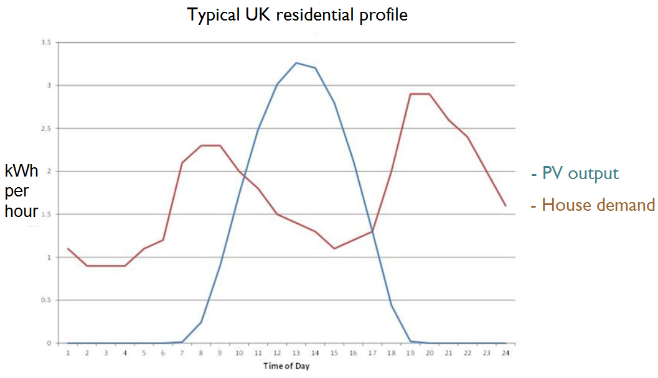

Figure 5: Typical PV yield vs typical electricity demand, UK residential

Diverters which prevent electricity export from households with PV arrays or wind turbines are already well established on the market: they monitor power flow at the grid meter and by modulating control (e.g. triacs) typically direct the PV surplus to dedicated immersion heaters.

An ASHP under the command of a diversion controller could “bank” 4 units of heat into thermal storage for each redirected unit of power; and, while this would require a variable speed compressor, in future all ASHPs will probably need to be thus fitted so they do not impose starting spikes on the local grid.

Discussion of diversion options

Different ways of storing heat will suit different situations: domestic hot water, building thermal mass, a water tank thermal store, or a phase change thermal store (compact wall-mounted units are coming to market). Or, indeed, other possibilities such as central heating radiators which incorporate thermal storage.

Alternatively, a “smart” and relatively compact battery (typically the Lithium Ion type) could be preferable; although as with heat pumps – and for similar economic and technological reasons – we contend that householders should not purchase batteries but lease them.

Choosing the best solution will always mean reconciling
- price per kWh of storage capacity,
- guaranteed number of storage cycles;
- consumption of materials (especially true of building thermal mass),
- the “footprint” of the storage technology.
We offer as a final thought (Figure 6) the possibly that, further developing the cassette concept, a heat pump supplier might interpose either a battery or a phase change thermal store between the heating module cassette and the standardised building interface – and, what is more, such a module could be retrofitted. Thus, an extra aspect of “future proofing” would be ensured.

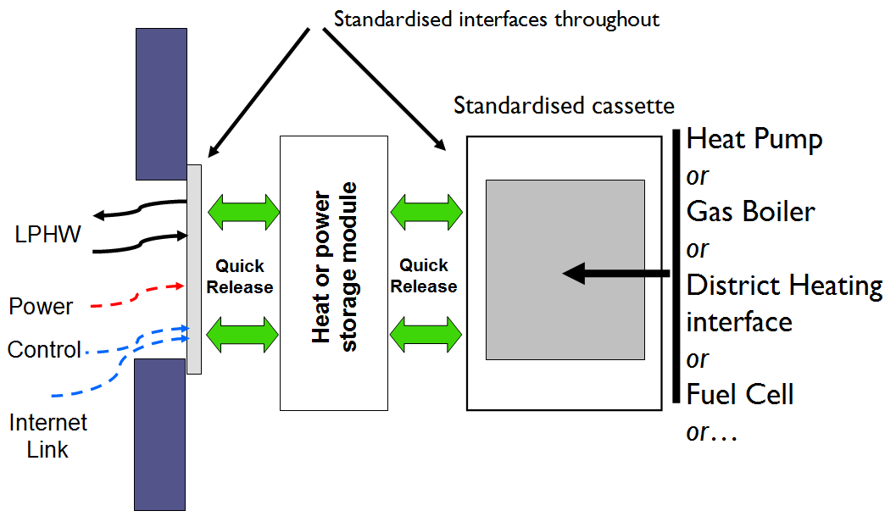

Figure 6: Cassette heating device plus compatible energy storage module

Reconciling efficiency targets and supply of power “drivers”: The Grid-Friendly Heat Pump

The authors, in conjunction with Dr Judith Evans of RD&T and Dr Robin Curtis of Geoscience Ltd, have developed the concept of the Grid-Friendly Heat Pump (GFHP) (Figure 7).

The GFHP performs two separate operations:
- firstly, the harvesting of ambient heat;
- secondly, the delivery of heat
It achieves this with a compound design, involving two entirely separate and independent stages (which might be charged with different working fluids). Also, the two stages might be separated by quite a large distance: in a housing association development, for example, there might be a central first stage ASHP heating a large underground intermediate thermal store (economies of scale); from it, water at e.g. 20°C could be circulated to individual premises, each having their own second stage water/water heat pump.

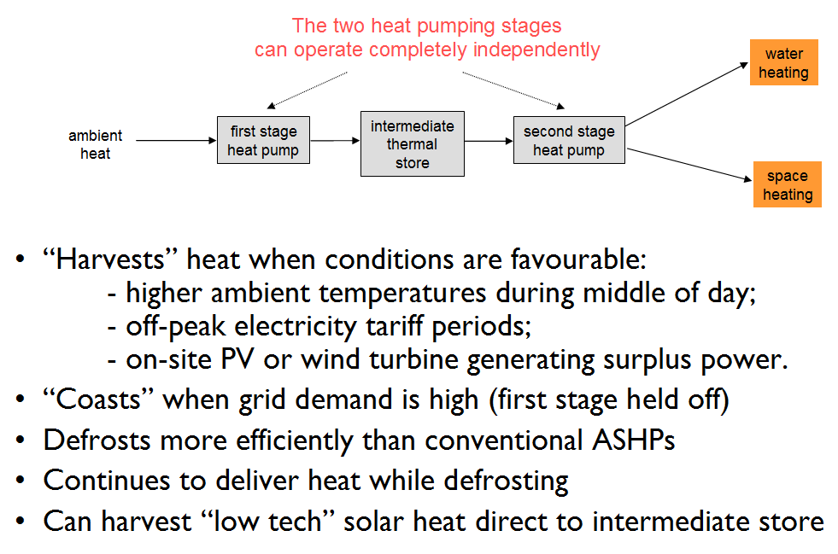

Figure 7: The Grid Friendly Heat Pump

The GFHP addresses many of the problems we have highlighted in this paper, by offering maximum flexibility as regards
- power price fluctuations;
- on-site power generation;
- “banking” of heat when the ambient temperature is most favourable.
Furthermore, it can be configured to receive heat (e.g. waste heat or energy from “low tech” solar collectors) directly into its intermediate thermal store, thus bypassing the first heat pump stage.

Problem 10: the cost of accommodating storage

Especially in British urban and suburban settings, the “footprint” of storage hardware could well prove a major issue: where the price of building land has to be factored in, it could be the accountant and not the building services engineer who holds sway when it comes to choosing between technologies. For this reason, we consider the Grid-Friendly Heat Pump with its large intermediate thermal store more appropriate to centrally-managed sites (e.g. housing association developments), lower density open market housing, and off-gas-grid settings generally.

Problem 11: uncertainties over UK energy policy

Whilst our Government is calling for the mass phase-out of gas heating in favour of heat pumps, we are not seeing the necessary investment in renewable electricity generation, because investors are uncertain about the direction of UK energy policy [5].
- New PV installed capacity was 950 MW in 2017, down from 1970 MW in 2016 and 4100 MW in 2015 [6].
- The Committee For Climate Change (CCC) has stated that UK consumers are being penalised because “there is no route to market for cheap onshore wind” [7]: a total of 794 onshore wind farm projects, fully designed and with planning permission, are currently on hold with a total capacity of 4466 MW [8].

Re the second point: onshore wind is now the cheapest of all electricity sources, fossil fuel generation and nuclear included [9]; and, crucially, wind power matches seasonal electricity demand – and UK space heating degree day curves – very well [10] (Figure 8).

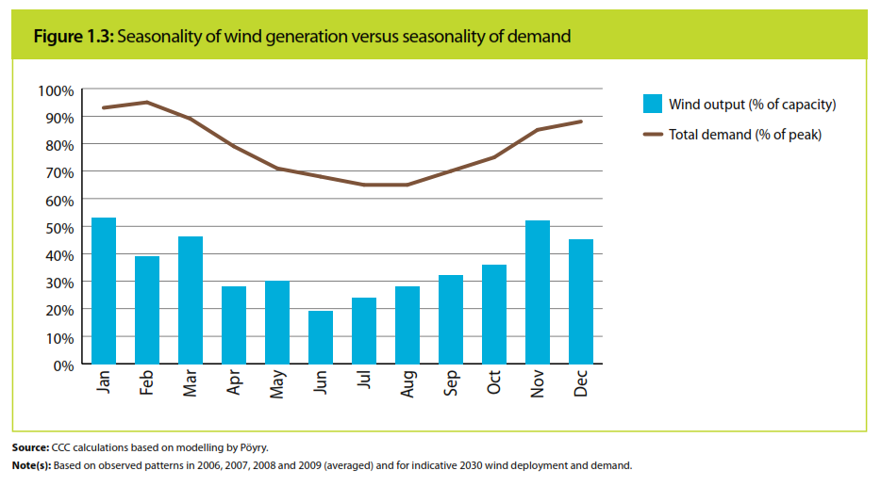

Figure 8: Seasonality of UK wind generation vs seasonality of UK electricity demand

Regarding offshore wind, prices have dropped so much that projects awarded contracts in 2017 came in cheaper than new gas fired generation [11] ; and a 2017 study [12] demonstrates that a total capacity of at least 25 gigawatts (GW) can be installed in UK waters by 2030 (Figure 9).

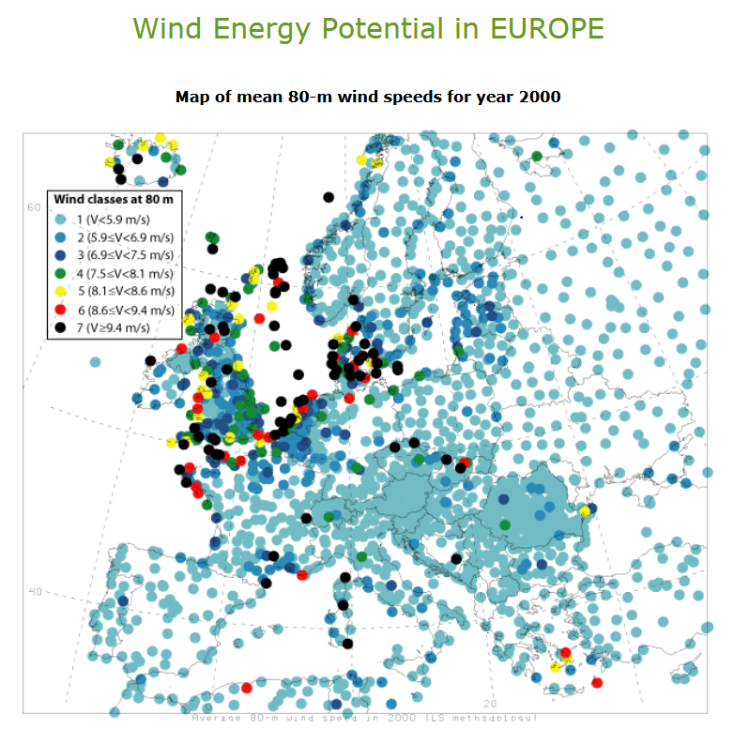
(Global Energy Network Institute)

Figure 9: European wind energy potential

Though it is obvious, this very important feature of wind power is worth stating: unlike PV, wind power availability is not daylight-dependent. Thus, via an Internet Of Things link-up, ASHP installations featuring thermal energy storage can
- run hard at night when the power price drop more than offsets the reduction in COP;
- as a result, reduce daytime pressure on the Grid, thus helping to hold down daytime power prices.
Furthermore, whenever the availability of renewable energy exceeds the “non-smart” demand, the National Grid operators could find that the ability to negotiate the wholesale powering up of heat pumps across the UK could help to stabilise both the whole system and regions within it.

Our industry should be lobbying hard in favour of wind power: it can provide the cheapest electricity, so it is key to making heat from heat pumps affordable; and, in general terms, it can provide that power when Britons will want to run their heat pumps. Not only that, but because a massive fleet of heat pumps under “smart control” can potentially absorb large grid surpluses at very short notice, the UK wind energy industry should in turn prove a potent advocate of heat pumps.

There is a very good reason why our industry should as soon as possible seek high-level involvement in energy policy negotiations, especially those concerning the Electricity Grid: the demand for electricity to power mass heat pump installations is going to coincide with a huge growth in the demand for clean power to charge all-electric cars. Was there ever a greater need for joined-up thinking?

CONCLUSIONS

The bulk transfer of UK domestic and commercial space and water heating from natural gas boilers to electric Air Source Heat Pumps requires a total re-think of both marketing and engineering.
- Heat pumps should be leased, and for broad public acceptance householders should not pay for the power that heat pumps consume; instead, the heat pump supplier must charge for the heat delivered.
- To overcome the “Achilles Heal” of Air Source Heat Pumps, their impaired performance at lower ambient temperatures, heat pump heated dwellings will have to be either provided with- or given access to energy storage.
- Demand pressure on the National Grid and local electricity distribution networks, and the inevitable move towards fully flexible power tariffs, will be another fact of life necessitating a “symbiosis” between heat pumps and energy storage.
- Local land price and size of building plot, rather than engineering and environmental concerns, could be key factors in choosing the means of energy storage.
- The Grid-Friendly Heat Pump could be one of the many technical solutions Britain will need if wholesale gas boiler phase-out is to be achieved in the medium term; one of its advantages is being able to split the heat harvesting and heat delivery functions, allowing many properties to share a common heat store.
- Flexibility will be the key to success: interchangeable heat source cassettes, open source software, and adaptability to continuously varying power prices and energy availability – whether within the property or from the grid.
- Our industry needs to get involved in UK energy policy-making at the highest level.

References

[1] CIBSE
[2] Energy Saving Trust March 2018
[3] Green Energy UK Tide tariff
[4] Octopus Energy Agile Octopus tariff
[5] University of Durham Energy Institute, June 2018
[6] SolarPowerEurope, quoted in The Guardian June 2018
[7] Committee For Climate Change, 2018 Progress Report to Parliament.
[8] RenewableUK compilation of wind power industry figures, January 2019
[9] Dept for Business, Energy and Industrial Strategy 2016 & BVG Consultants for Scottish Power 2018
[10] Committee For Climate Change, Renewable Energy Review (2011)
[11] BEIS quoted by Carbon Brief, September 2017
[12] RenewableUK report on Unleashing Europe’s Offshore Wind Potential (BVG Associates)

